**Name:** **Shrouk Ali Elsaid Ali Abo Elenen**

**ID: 4221153**

**Group: C1**

**Task3 DBMS:**

* **Make a research on MySQL storage engines with a brief explanation for each type**

1. **A storage engine is a software module that a database management system uses to create, read, update data from a database. There are two types of storage engines in MySQL: transactional and non-transactional.**

* InnoDB: is the most widely used storage engine with transaction support
* MyISAM: is the original storage engine. It is a fast storage engine.
* CSV: stores data in CSV files. It provides great flexibility because data in this format is easily integrated into other applications.
* Merge: Merge tables help manage large volumes of data more easily.
* Archive: storage engine is optimised for high speed inserting. It compresses data as it is inserted. It does not support transactions.
* Federated:  offers the ability to separate MySQL servers to create one logical database from many physical servers.

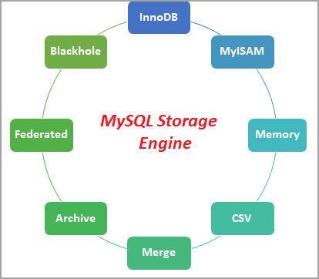

* **Create a database (Market)**
* **Create tables in the image**
* **Create a primary key for every table**
* **Make relations between the tables using foreign keys**

